**RSE2107A - Synthesizing Possible Solutions**

Introduction

* This document builds upon prior from Identifying and Understanding Problems and Opportunity to propose feasible solutions to address the project’s design, navigation, and integration requirements. It evaluates multiple approaches for arena construction and robot behaviour within defined constraints.

System Boundaries

* In line with the system approach, this section identifies key components which will be expanded upon to explain their roles and interactions between the system and surrounding environment. Establishing these boundaries ensures our solutions stay focused and stay fit within our project limits.
* Arena Layouts, Elements & Obstacles
* Materials & Visual Treatments
* Navigation Stack
* LIMO Bot

Arena Layouts, Elements & Obstacles

* Our given theme was Changi Airport Terminal 3. Thus, our team proposed several design themes. We aim to create a plot that is aesthetically pleasing to simulate real-world settings. Obstacles were proposed as well to test the LIMO bot’s ability to move around safely, avoid objects, and perform recovery behaviours when needed. Elements were proposed to enhance our plot that reflect actual features of the airport.
* Arena Theme
  + Terminal 3 Departure Hall
  + Butterfly Garden
  + Crystal Garden
  + Indoor Playground
* Elements
  + Terminal Shell
  + Daisy
  + Floral Inspirations
  + Airline Counters
* Obstacles
  + Static Gantry
  + Low Hump
  + Handrails
  + Boundary Barriers
  + Conveyor Belt
  + Acrylic panels

Materials & Visual Treatments

* Our team proposed a variety of materials to construct the arena and support robot performance. Our reason for selection of base materials is to focus on structural strength and ease of handling. Different floor textures simulate real-world surfaces and also help with traction during navigation. Design elements and visual treatments were used to enhance appearance, and to construct obstacles easily detectable for the LIMO bot.
* Base Material
  + Acrylic sheet
  + Cardboard sheet
  + Foam sheet
* Floor Texture
  + Smooth vinyl sheet
  + Textured EVA foam
  + Rough sandpaper
* Design Elements
  + PVC tube
  + Cardboard
  + Air-dry clay
  + 3D printed parts
  + Acrylic
  + PETG tubes
* Visual Treatments
  + Vinyl tape
  + Spray paint
  + Sandpaper

Navigation Stack

* Within the navigation stack boundaries, our team implemented a set of ROS1 stacks to enable the LIMO to map its surroundings, localize its position, plan safe routes, and recover from unexpected obstacles. These functions work together to ensure autonomous movement through the arena, even in the presence of uncertain conditions.
* SLAM
  + Gmapping
  + Cartographer
  + RTAB
* Localization
  + AMCL
* Move_base
  + Global planner
    - Dijkstra’s Algorithm
    - A*
  + Local planner
    - DWA
    - TEB
* Recovery Behaviour
  + Reverse & Replan
  + Rotate & Scan
* Rviz & Gazebo
  + Actionlib

LIMO Bot

* Our team proposed LIMO bot to fall within the system boundary as it is the main platform used for testing autonomous navigation. It provides multiple drive modes, enabling different behaviours for navigation. Its integrated LiDAR, encoders, and IMU delivers key data for localisation and work smoothly with the ROS1 stack. Using the LIMO bot provides flexibility to select the most suitable setup for navigating all eight terrain plots.
* Wheel Configuration
  + Differential
  + Ackermann
  + Omni‐directional
  + Track
* Sensors
  + LiDAR
  + Wheel Encoder
  + Inertial measurement unit (IMU)

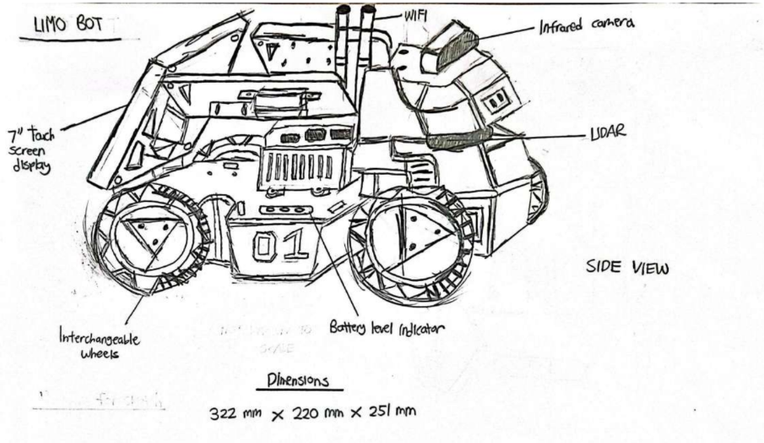

* Our team drew the LIMO bot sketch to serve as a visual representation to enhance our understanding of the physical structure, component placement, and modular features of the robot.